Zoe Kim and Marc Creixell
Bioengineering 188
March 21, 2019

Predicting cell phenotypes using signaling signatures
MOTIVATION
Phosphorylation-based cell signaling regulates many of the cell behaviors that are aberrant in cancer and that serve as key hallmarks of tumorigenesis and tumor progression¹. This is why protein kinases and in particular receptor tyrosine kinases (RTKs) are poised as attractive drug targets and have been a major focus in clinical research. However, although initially effective, therapies targeting RTKs are usually short-lived due to the activation of many non-targeted RTKs and subsequent induction of cell proliferation and survival signaling pathways. In addition, bypass switching to alternative pathways may endow cells with new and crucial cell phenotypes for tumor development. For instance, RTK AXL has been reported not only to sustain cell survival in the presence of EGFR-therapies, but also to direct tumor migration and support an immunosuppressive tumor microenvironment. Even though studies have identified a handful of key RTKs driving bypass resistance and promoting cell malignancy, a more fundamental understanding of network-level bypass signaling will be required to better inform the design of prognostic assays for identifying effective therapy combinations in individual tumors. To this end, we aimed to computationally investigate the possible correlation between cell signaling signatures exhibited by different cell populations grown under different culture conditions and experimentally-obtained resistance phenotypic indicators, namely cell viability and AXL expression.

PROBLEM DEFINITION AND OBJECTIVES
The dataset we analyzed contains mass spectrometry (MS) generated phosphorylation measurements of 300 signaling proteins (variables) under 10 culture conditions in PC9 wild type (WT) and PC9 AXL knockout (KO) cells (observations). In addition, we used cell viability measurements of 6 of the 10 cell culture conditions (data extracted from Manolis et al.² and provided by Song Yi Bae), and measured AXL expression levels by flow cytometry matching all 10 growing conditions under which the MS assay was performed (Fig. 1).

Our first aim was to assess whether there is a significant relationship between these phosphorylation measurements and cell viability or AXL expression. In addition, kinase specificity studies have shown that not only SH2, and SH3 domains, are relevant in driving substrate motif recognition, but also the kinase domain itself³. There, using a specificity screening to find the optimal substrate motif peptide sequence of an individual kinase, they found that some of the 5 amino acids downstream and upstream the phosphorylation site are key contributors of specificity. Therefore, we hypothesized that phosphopeptides with similar sequences neighboring the phosphorylation site could be recognized by the same set of protein kinases and thus show similar phosphorylation behaviors across the different cell populations. Interestingly, this would allow for the identification of groups of signaling proteins regulating our cell phenotypes of interest.
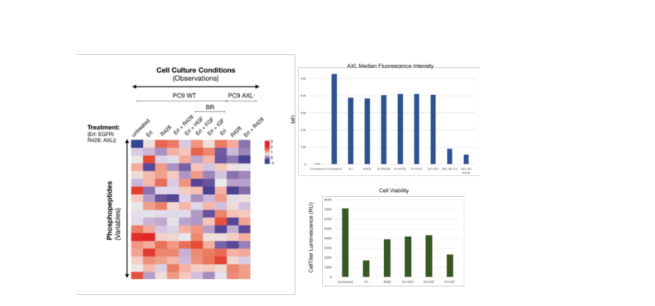
A
B
Figure 1. Data set. A MS-based phosphorylation data across different cell culture conditions. B AXL expression levels measured by flow cytometry. C cell viability quantified by CellTiter-Glo luminiscent assay.

METHODS
Initially, a partial least squares (PLSR) model was generated to provide regularization, predictive capability, and visualization of variable relationships with the phenotypes. Using scikit-learn’s PLSRegression class, after fitting to our regularized data, we used the score method to generate R2Y, the ___, across an increasing number of components. Similarly, to generate Q2Y, the ___, we implemented leave one out cross-validation, using each training and testing set generated to generate a cumulate Q2Y value. The number of components for PLSR was decided to be the point at which these two values were effectively maximized.Running PLSR for each phenotype resulted in two sets of scores and loadings plots. To increase interpretability of the loadings plot, we decided to cluster the variables.

Clustering was conducted using scikit-learn’s KMeans class on sequence similarity calculated with a Point Accepted Mutation (PAM) 250 matrix. More specifically, the distance calculation was adapted from methods previously developed by Adam Weiner⁴. The use of transition matrix PAM enables the pair-wise calculation of sequence distance accounting for the structural and biophysical consequences of different residues being present in both sequences. The sequences were first processed such that only the three amino acids surrounding upstream and downstream the phosphorylation site would be analyzed, thus assuming that their proximity indicated a greater role in kinase specificity. If any amino acids were missing, they were randomly generated, and the resultant sequences were formatted into a FASTA file. The Distance class defined in distance.py was initialized by inputting this FASTA file and “PAM250” to specify the implementation of this substitution matrix (outlined in sub_matrix.py). The distance matrix attribute was then called as the input to kMeans, thus creating the specified 25 clusters.

Finally, a new PLSR model was generated using the average phosphorylation measurements in each culture condition among each cluster. Explicitly, these averages reduced the number of variables to 25, but the number of observations and phenotypic measurements remained the same.
RESULTS
PLSR predicts AXL expression but fails to predict cell viability
By assessing the predictive capabilities of our PLSR models, we found that AXL expression is acceptably predicted with saturating Q2Y values of 0.808 at 3 components and a decent correlation between predicted versus measured expression levels (Fig. 1a and b left). However, the PLSR model failed to predict cell viability, indicated by consistent negative Q2Y values by testing model performance while varying the number of components from 1 to 4. Likewise, no correlation was observed between the predicted versus the measured cell viability (Fig. 1a and b right). It is worth noting that only 6 observations were fitted to the cell viability PLSR model for the 300 variables whereas in the AXL PLSR model 10 observations were included for the same number of variables. The generated scores and loadings plot for both PLSR models show covariations with respect to principal components (PC) 1 and 2 consistent with what we would expect. Regarding the AXL expression model, we observe AXL KO cell populations varying in the opposite direction than the AXL expression loading from PC1 and 2. Interestingly, the cell population treated with erlotinib and HGF and FGF show similar covariation than the AXL expression loading which is not the case for the IGF driven bypass resistance cell population. Similarly, the cell viability PLSR scores and loadings plot show the negative effect of erlotinib in cell viability, which is partially rescued by the administration of HGF and FGF. It seems unrealistic, however, that the R428 cell population position in the scores plot suggests a positive causal relationship with cell viability. This might be due to lack of cohesion between the cell viability measurements obtained from disparate sources (Fig. 2c).

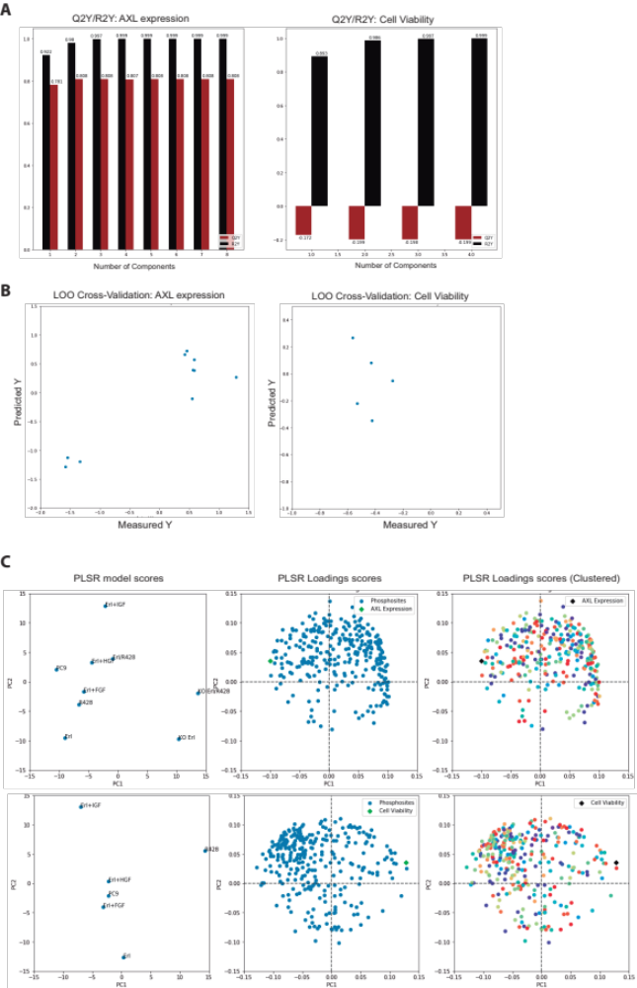
Figure 2. PLSR model clustered by sequence similarity. A Q2Y and R2Y values across different number of PLSR components for AXL expression (left) and cell viability (right). B Leave-one-out cross-validation results for both PLSR models. C Scores (left) and loadings (center and right).
Protein Clusters based on sequence similarity do not show similar phosphorylation behaviors
Next, we tested our hypothesis that protein clusters grouped by sequence similarity would show similar phosphorylation behaviors, and thus differentially affect AXL expression and cell viability. Unfortunately, we did not see any clear separation or pattern based on protein clusters in our PLSR loading plots (Fig. 1c right). As explained below, further refinement of our clustering method will be carried out to overcome the current limitations of our data set.
Averaged clusters provide insights about the effect of identifiable proteins on cell phenotypes
Based on the clustering results, we obtained averaged phosphorylation levels across all conditions for each cluster and fitted our PLSR models with these new data sets. Thereby, our updated data sets contained 25 variables and 10 observation in the AXL model, and 25 variables and 6 observations in the cell viability PLSR model. Although these averaged data sets are significantly less underdetermined than the complete data set, the predictive capabilities of both models showed decreased Q2Y values; saturating at 0.6 at 3 components for the AXL expression PLSR model and consistently remaining below -0.2 in the cell viability model (Fig. 2a). Again, the AXL model showed a reasonable correlation between the predicted against the measured expression levels whereas the cell viability model resulted in no correlation.
After fitting the model, the 25 protein clusters could then be clearly visualized and assessed for its covariation with respect to the cell phenotype in both loadings’ plots. In both models, most of the protein clusters seem to covert remarkably different except from I few which seemed to affect the cell phenotypes. Interestingly, we see that the model predicts proteins in clusters 12 and 15 to positively affect AXL expression whereas they negatively affect cell viability. have been reported to be important mediators of tumor development. Conversely, cluster X is predicted to negatively affect AXL expression. In addition, protein cluster 23 and to a lesser extent cluster 8, lie in the same direction of maximal variation than cell viability, which may suggest that these groups of proteins may have a positive effect in driving this phenotype. A list with the members of the mentioned protein clusters can be found in table 1. However, as discussed above, it is worth noting that caution must be taken when interpreting the results from the cell viability PLSR model given the poor model fitness (Fig. 2a and b).
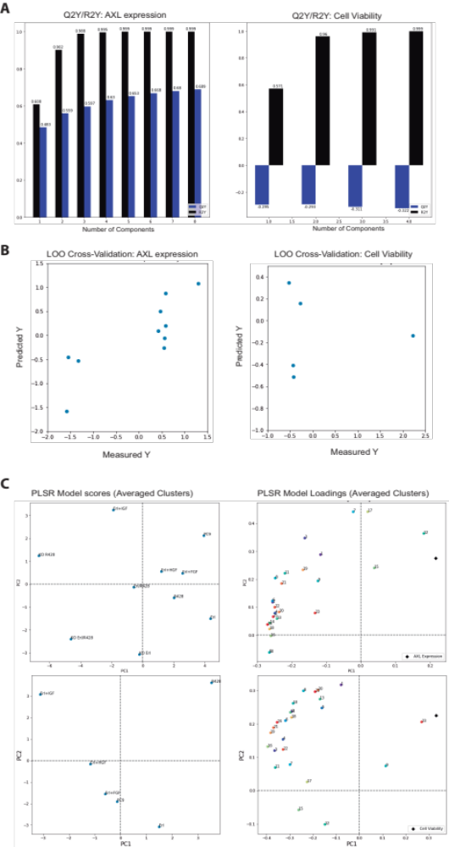
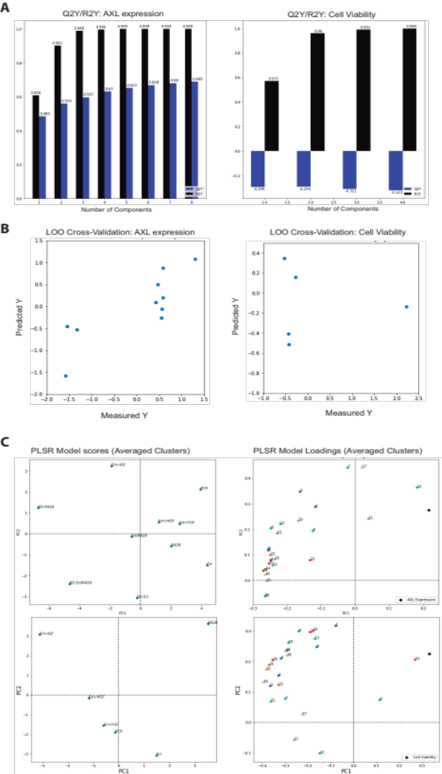
Figure 3. PLSR model fitted by cluster averages. A Q2Y and R2Y values across different number of PLSR components for AXL expression (left) and cell viability (right). B Leave-one-out cross-validation results for each PLSR model. C Scores (left) and loadings (center and right).

Cluster | Protein Name | Phosphopeptide Sequence
12 | Palmitoyltransferase ZDHHC7 | eYMESLQLkPGEVIyk-0
12 | Phosphatidylinositol 3-kinase regulatory subunit alpha | dQyLMWLTQk-0
15 | GRB2-associated-binding protein 1 | dASSQDcyDIPR-0
15 | GRB2-associated-binding protein 1 | kDASSQDcyDIPR-0
15 | Cofilin-1 | hELQANcyEEVkDR-0
15 | Filamin-A | vHSPSGALEEcyVTEIDQDkYAVR-0
15 | Filamin-B | sSTETcySAIPk-0
15 | Actin, cytoplasmic 1 | lcyVALDFEQEMATAASSSSLEk-0
15 | Hepatocyte GF-regulated tyrosine kinase substrate | vcEPcyEQLNR-0
23 | Actin, cytoplasmic 1 | syELPDGQVITIGNER
23 | Anion exchange protein 2 | sYGEEDFEyHR
23 | Tyrosine-protein kinase Lck | sVLEDFFTAyEGQYQPQP
23 | Sodium-coupled neutral amino acid transporter 2 | fSISPDEDSSSYSSNSDFNySYPTk
Table 1. Proteins pertaining to clusters 12, 15, and 23
DISCUSSION

Here, we aimed to explore the correlation between the phosphorylation status of cell populations cultured under different conditions and the extent of AXL expression and cell viability. In addition, we also aimed to identify potential signaling proteins involved in driving our cell phenotypes of interest by leveraging PLSR and clustering methods.

Limitations of our PLSR models and Next Steps

Although the AXL PLSR models showed acceptable model fitness, we found negative Q2Y values across any number of components for cell viability (Fig. 1a and 2a), suggesting the breakdown of PLSR due to the significant difference between the number of variables (300) and observations (6). Surprisingly, when evaluating the fitness of the PLSR models fitted with the averaged phosphorylation levels of all proteins present in each one of the 25 clusters, thus obtaining a new data set of 25 variables and 10 (AXL) or 6 (cell viability) observations, we found a worse model performance in all cases than when fitting all 300 variables. This clearly limits our ability to interpret the model predictions of proteins affecting cell viability, and thus caution must be taken when analyzing the model predictions. We think of two further plausible scenarios that explain the breakdown of PLSR when trying to predict cell viability but not AXL expression. First, the quality of the viability measurements is questionable since the data was obtained from disparate sources and thus data cohesion might affect our analysis. This is reinforced by the fact the resulting loadings plots in the cell viability PLSR models show that treatment of R428 positively affect cell viability, which is not realistic (Fig. 1c and 2c bottom left). Second, it is also feasible that no correlation can actually be established between the signaling signatures and the observed cell viability. Therefore, an immediate next step is to generate new cell viability measurements matching all 10 culture conditions and evaluate the PLSR model again in order to improve the quality of the data but also increase the number of observations. Likewise, even though the AXL PLSR models performed acceptably in predicting protein expression, the phosphorylation form of AXL is indicative of AXL activation - and its phenotypic consequences - rather than cell surface receptor abundance. Thereby, measuring pAXL levels across all culture conditions would be valuable.

Limitations of sequence similarity calculation and Next Steps

In regards to our sequence similarity computation, as explained in our methods section, the resulting distance accuracy and reliability was affected by limitations on our phosphopeptide sequencing data. The assignment of random amino acids to the sequences lacking any of the surrounding six amino acids from the phosphorylation site could potentially bias our distance calculations and thus our clustering. To overcome this, we propose either (i) find the bug preventing us from disregarding distance calculation when a residue within the motif sequence is missing, or (ii) find a way to incorporate the correct amino acids in these sequences by mapping them from proteomics databases such as Uniprot. Nevertheless, despite this limitation, repeated runs of our program provided consistent clustering results and PLSR outputs. In addition, given the assumption that lowercase residues within the phosphopeptide sequences correspond to low quality/accuracy sequencing results, we could attempt to further improve distance calculation by weighting more uppercase residues.

Conclusively, even though the aforementioned analysis limitations prevent us from digging any deeper on the interpretation of the predicted signaling clusters driving our cell phenotypes of interest, these study shows that, after overcoming these issues, our methodology could help unravel the network-level signaling state of bypass resistant tumors.

REFERENCES

1. Hanahan, D. & Weinberg, R. A. The hallmarks of cancer. Cell 100, 57–70 (2000).
2. Manole, S., Richards, E. J. & Meyer, A. S. JNK Pathway Activation Modulates Acquired Resistance to EGFR / HER2 – Targeted Therapies. 5219–5229 (2016). doi:10.1158/0008-5472.CAN-16-0123
3. Begley, M. J. et al. EGF-receptor specificity for phosphotyrosine-primed substrates provides signal integration with Src. Nat. Struct. Mol. Biol. 22, 983–990 (2015).
4. https://github.com/adamcweiner/flu-vax/tree/master/fluv

